Assignment No. 4

Title of Assignment: You have a business with several offices; you want to lease phone lines to connect them up with each other; and the phone company charges different amounts of money to connect different pairs of cities. You want a set of lines that connects all your offices with a minimum total cost. Solve the problem by suggesting appropriate data structures.
Relevant Theory:
Spanning Tree: A spanning tree for a connected graph G is a tree T containing all the vertices of G.
. 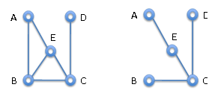
G T
Minimum Spanning Tree: A spanning tree whose weight of edges is minimum is called as Minimum Spanning Tree.
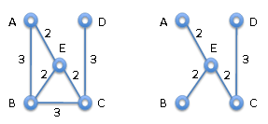
Two Methods to find Minimum Spanning Tree:

Prims Algorithm:
This algorithm is used to find minimum spanning tree and minimum cost of spanning tree.
Steps:: 1) This algorithm starts with start vertex.
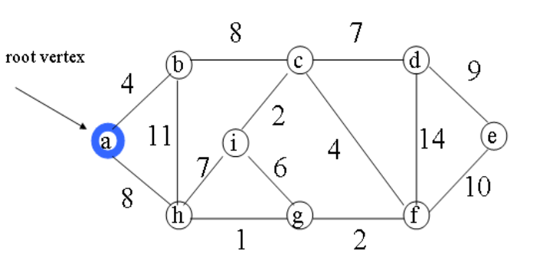
2) Then it finds edge which has minimum weight.
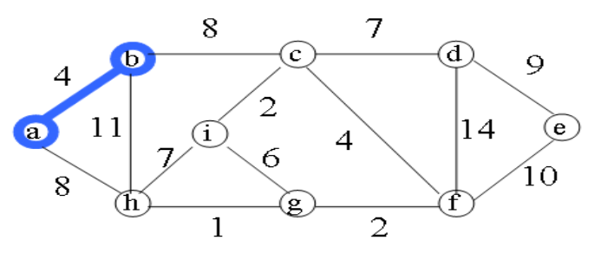
- It continues the finding such that one vertex of edge is already visited & another vertex is not visited with minimum weight.
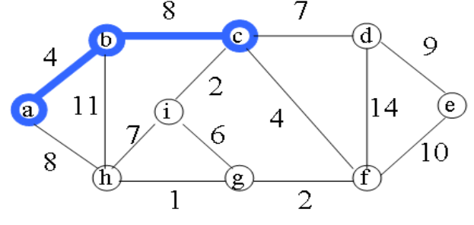
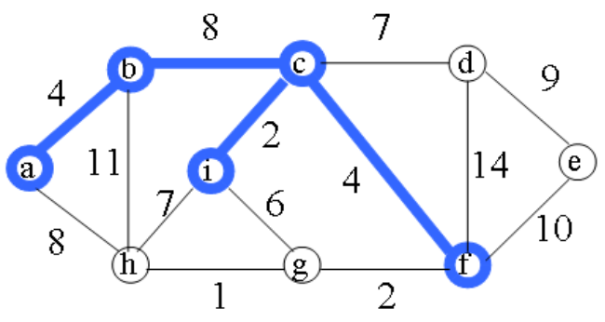
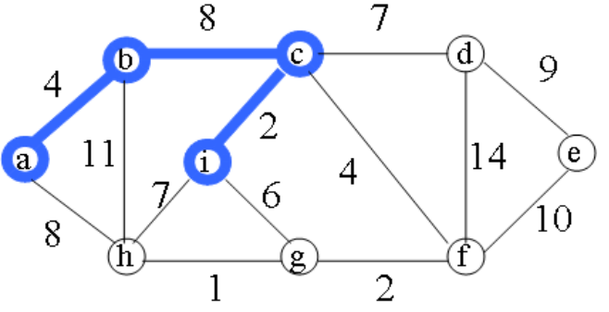
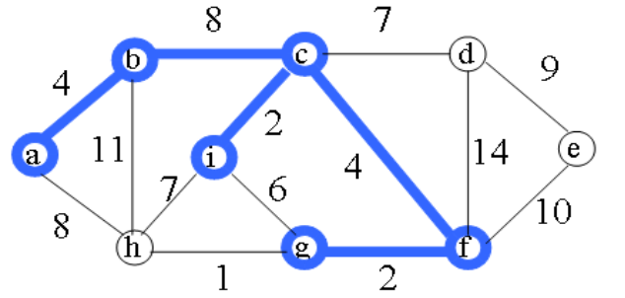
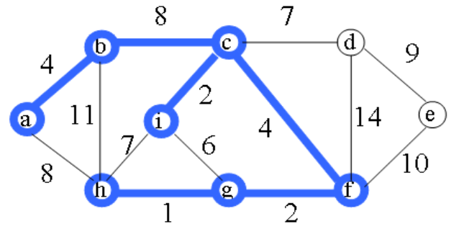
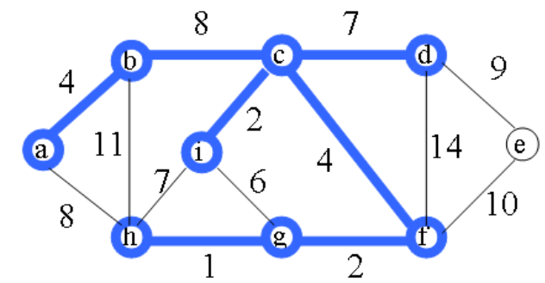

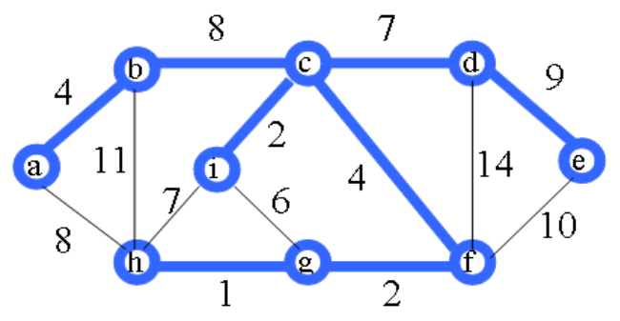
- These steps are repeated to cover all the vertices of graph.

2. Kruskal’s Algorithm
This algorithm is used to find minimum spanning tree and minimum cost of spanning tree.
Steps:: 1) This algorithm starts with edge with minimum weight. AD and CE are the shortest edges, with length 5, and AD has been arbitrarily chosen, so it is highlighted.
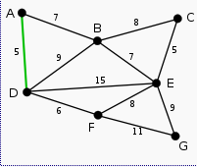
2) CE is now the shortest edge that does not form a cycle, with length 5, so it is highlighted as the second edge.
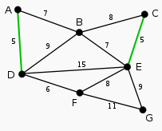
3) The next edge, DF with length 6, is highlighted using much the same method.

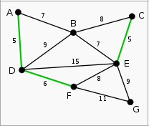
4) The next-shortest edges are AB and BE, both with length 7. AB is chosen arbitrarily, and is highlighted. The edge BD has been highlighted in red, because there already exists a path (in green) between B and D, so it would form a cycle (ABD) if it were chosen.
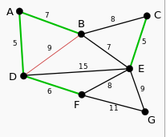
5) The process continues to highlight the next-smallest edge, BE with length 7. Many more edges are highlighted in red at this stage: BC because it would form the loop BCE, DE because it would form the loop DEBA, and FE because it would form FEBAD.
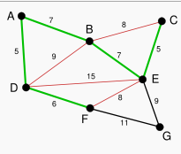
6) Finally, the process finishes with the edge EG of length 9, and the minimum spanning tree is found.
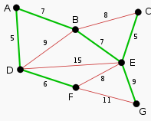

Application of Minimum Spanning Tree:
Minimum spanning trees are useful in constructing networks, by describing the way to connect a
set of sites using the smallest total amount of wire.

Mathematical Modelling:
Let I be an input = { n, wt, x}
Where n is number of lanes, wt is matrix stores distance between lanes and x is start lane to deliver newspaper.
Let O be an Output as O= f (I)
where f is function as
P is a set of vertices which represents path of Prims Algorithm ={x}
V is set of visited vertices = {x}

P = P U y & V = V U y
Where i is vertex such that
n ( Min (wt [x,y] ) and y ∉ V and x ∉ V
Testing:
Test Conditions:
Give number of lanes and the distance between lanes.

Input:
Read number of lanes and the matrix which will store the distance between lanes.

Output:
The path which have minimum distance.

FAQs:
- What is Spanning Tree?
- What is Minimum Spanning Tree?
- What is Prim’s Algorithm?
- What is Kruskal’s Algorithm?
- What are Applications of Minimum Spanning Tree?
- How to decide whether to select Kruskal’s algorithm or Prim’s algorithm?
Conclusion: Prims Algorithms is successfully implemented.

